**Flight Simulator Operator’s Console – High-Level Overview**

This document provides an overview of the proposed functionality for a flight simulator operator's console. It is intended to gather feedback on potential additions and corrections to reach a consensus on operational requirements that will guide software development.

A figure accompanying this document illustrates an example of the flight simulator operator's console.

**Assumptions**

1. The operator’s console serves as the central interface for controlling and monitoring the simulator, ensuring safe and effective operation.
2. The user experience should allow operators to manage all key simulator functions without detailed knowledge of the motion platform or X-Plane software.
3. The operator’s console will complement a separate **X-Plane flight management console**, which provides full control of X-Plane for users familiar with X-Plane software.
4. The simulator will operate using three computer systems:
   * **Laptop 1:** Runs X-Plane 11.
   * **Laptop 2:** Runs the X-Plane flight console, allowing optional flight configuration.
   * **Small Computer (e.g., Raspberry Pi):** Runs the motion platform software and the operator’s console.
5. To ensure redundancy, the simulator software could be installed on both laptops so that operations can continue even if one system fails on an event day.
6. The console footprint will be no larger than a small laptop.
7. Connectivity will be through ethernet to a hub that also connects X-Plane and the motion platform

**Operator’s Console – Key Functions**

The operator’s console should:

1. Display **motion platform safety interlock status** including: wheelchair and platform dock status.
2. Display **X-Plane connection status**.
3. Provide options to select **flight scenarios** preconfigured by Coventry for beginner, intermediate or advanced users for: Level Flight, Take-off or Landing
4. Allow all X-Plane settings to be adjusted or overridden at any time by the X-Plane flight console.
5. Provide an option to **enable mild motion** for sensitive users or **disable motion entirely**.
6. Start the currently selected **X-Plane flight and motion platform**.
7. Pause an **X-Plane flight and motion platform**, allowing resumption from the paused state when ready.
8. End an **X-Plane flight and return the motion platform** to the loading position.

**Preconfigured Flight Situations**

Preconfigured flight situations are snapshots of an X-Plane state that include all significant aspects of the aircraft and environment, such as: Aircraft location, Weather conditions, System status (e.g., faults, failures).

These scenarios allow for quick setup of specific training or experience levels.

Example of a touch screen display for the operators console.

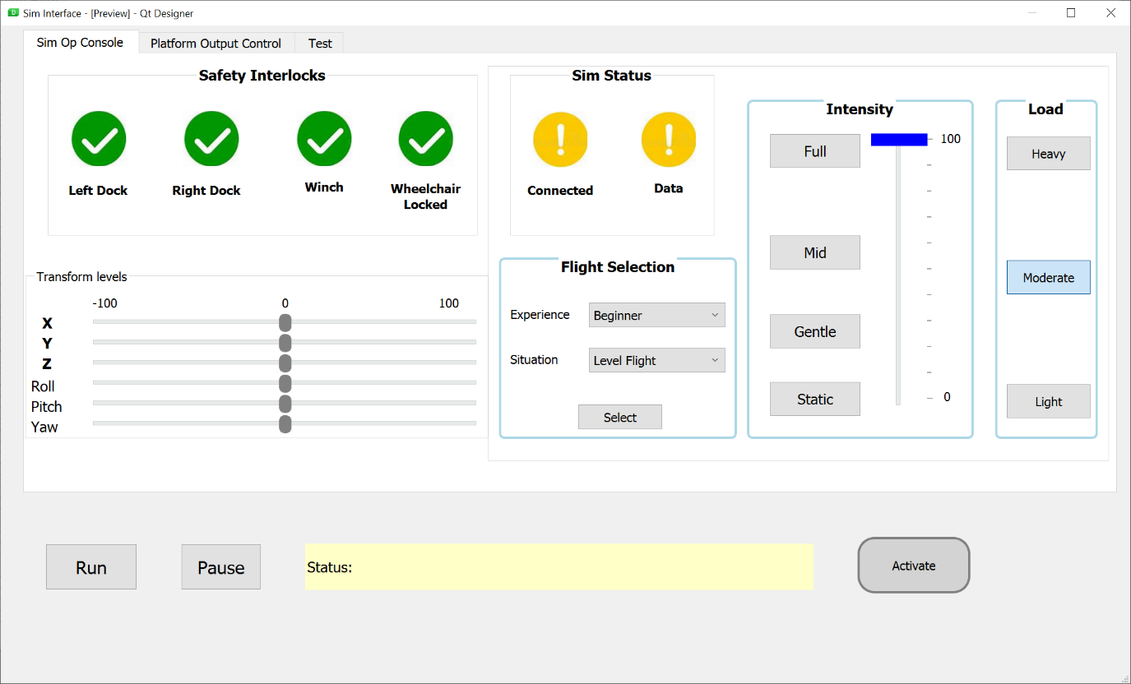

Example of a console derived from the current Middlesex University motion sim control panel with example display and hardware switches for Falcon 2.

